Spelling Flowers  Draw a big flower with ten petals. Write each of your spelling words on one of the petals. | Create a Word Search  Write your words in boxes (ask for squared paper). Fill in the rest of the boxes with random letters. Write the spellings underneath and challenge a family member to complete your wordsearch. | Red Consonants/Blue Vowels  Write out each of your words. Go over the consonants in each word using red pencil and go over the vowels in each word using blue pencil. | Three Times  Write each spelling word three times. First, write each word in pencil.  Second write each word in coloured pencil.  Third, write each word in pen. | Adding my Words  Each letter has a value.  Consonants are worth 10.  Vowels are worth 5.  Write your spelling words. Then add up the value of each spelling word.  Example-  said- 10 + 5 + 5 + 10 = 30
Technology  Use your home computer to type your spelling words. Be creative and use fun fonts and colours. Print out or have a go on the blog. | Across and Down  Write your words across and down sharing the same first letter.  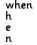 | Fancy Letters  Write each of your words using fancy letters. Your letters could be curly, dotty… or whatever you decide. | Pyramid Writing  Write each of your words in the shape of a pyramid. The first letter at the top, then first two letters underneath and so on.. | Sentences  Choose 5 of your spelling words. Write a detailed sentence for each. Underline the spelling word.
Change  Ask for a shopping receipt.  Choose different items to add together and work out how much change you would get from £10 or £20. | Number Bonds  Write down some different number bonds to 100 or extend to 1000.  e.g. 56 + 44; 320 + 680 | Revision Poster  Devise a revision poster to help your classmates learn about some of the topics we have covered in maths. Use BBC Bitesize for some ideas.  Doubling and Halving  Write down 20 two-digit numbers between 15 and 99. Double the numbers.  Write down 20 even numbers between 50 and 100, Halve the numbers. | Time  A family are driving from London to Edinburgh. The drive takes 7 hours and 38 minutes. They want to arrive in Edinburgh before 5 pm. If they leaves at 11.15am am, will they arrive in Edinburgh on time? | Measuring  Draw a picture with a ruler, using straight lines only. E.g. robot or house. Measure each side in mm then convert to cm by dividing by 10.  Find and measure five objects in your house. Put your measurements into a table. What would your column headings be?.  Draw a simple scale plan of the classroom and estimate and label the measurements.
Rounding  Write down 20 prices under £10. Round to the nearest £.  e.g. £3.56 - £4; £8.25 - £8 | Years, months, weeks, day  How long have you been at CTK? Answer as accurately as you can. Try to use the exact (or close to) number of months, weeks, days or even hours or minutes!. |  | Co-ordinates  Draw a 10 by 10 grid (x and y axes) and label the axes with numbers 1-10. Plot the points: (2,2) (3,5) (6,2) (7,5). Join the points. What type of quadrilateral have you drawn?
My Ideal Job  Create a poster to explain what your ‘ideal job’ would be and why you want this job when you are older. Research the qualifications or experience you need to achieve this job | Letter  Write a letter or draw a poster to the current Year 4, telling them what to expect in Year 5/6 in September. | Quiz  Use your knowledge of volcanoes and earthquakes to create a quiz for a friend or family member! You should ask about 10 questions. | Earthquakes  Write a short paragraph explaining what happens before, during, and after an earthquake. Include at least three key facts. Add a labelled diagram to support your explanation. | Belonging Word Cloud  Create a word cloud with words you associate with belonging and kindness 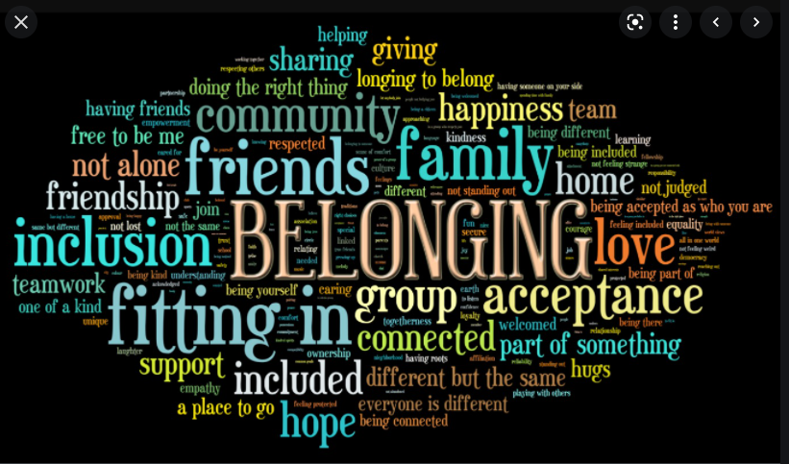
The Tudors  Design a Tudor-style artefact. You could create a royal portrait, a coat of arms, or a menu for a Tudor feast. Include details inspired by the Tudor period and label key features. Add a short explanation of what your artefact shows about Tudor life. | Diary  Write a diary entry about what you did over the weekend. It could be a day spent chilling at home or a fun day out. Make sure it is chatty, informal and punctuated correctly. | Floodland  Write a recount of Zoe’s escape from Norwich in her rowing boat, or create a comic strip style sequence of events. | Family Tree  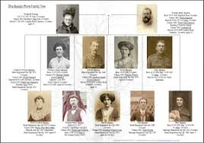  Create a family Tree for your family or for a famous person. | Book Review  Write a book review for a book that you would recommend to your class. Include the author, illustrator, genre, briefly describe the plot explain who your favourite character is and why, who might enjoy the book and any books or stories it reminds you of.
The weekly spelling list will be on the class page on the school website.

