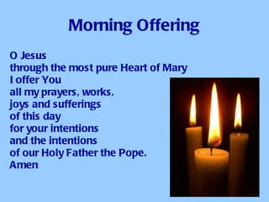

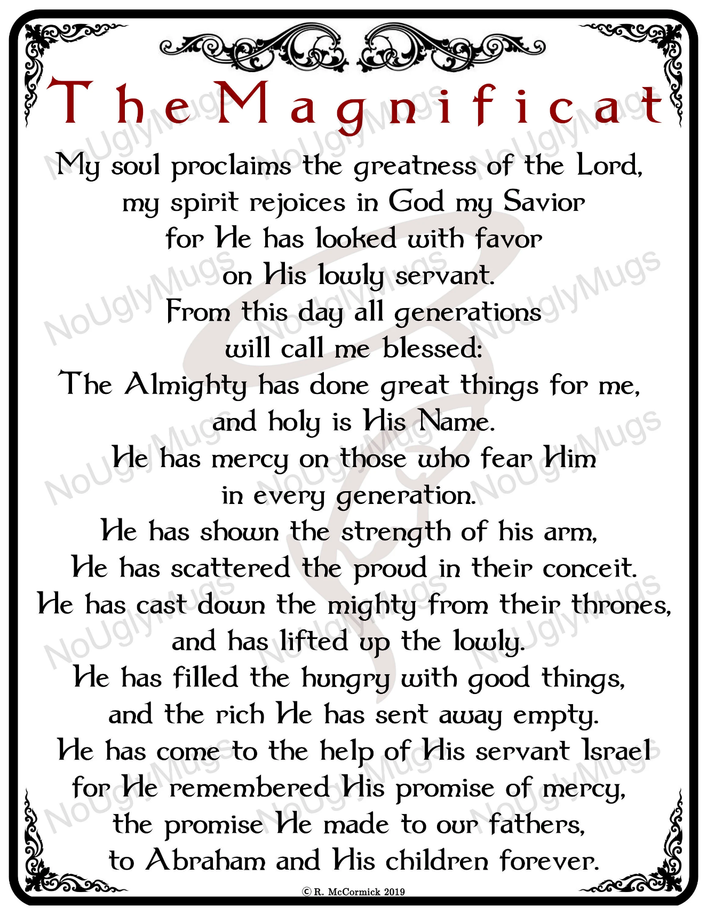



Act of Faith
My God, I believe in you
and all that your Church teaches,
because you have said it and your word is true.



Act of Hope
My God, I hope in you,
for grace and for glory,
because of your promises, your mercy and your power.



Love
My God, because you are so good,
I love you with all my heart,
And for your sake,
I love my neighbour as myself.



