 | Term 1 | Term 2 | Term 3 | Term 4 | Term 5 | Term 6
Topic  Cycle A | 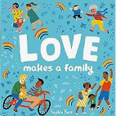  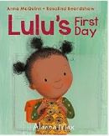  Marvellous Me | Let’s Celebrate  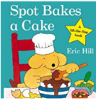  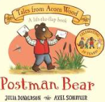 | 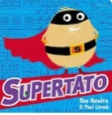  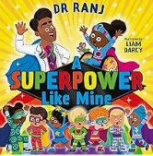  Superheroes Rule! | 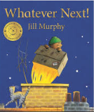  Brilliant Books | 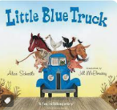  Terrific Transport  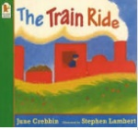  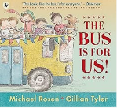  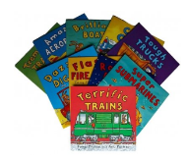 | 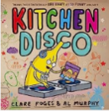  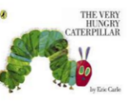  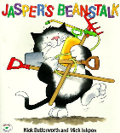  Our Wonderful World
Focus Books  See also separate document ‘Books covered per term’ | -Where’s Spot  -Lulus first day  -Loves makes a family  -Happy in our skin  -Senses | -Spot bakes a cake  -Peppas Diwali  -Maisy goes to a wedding  -Spot’s First Christmas  -A World of Festivals | -Supertato  -A superpower like mine  -Non-fiction books; people who help us | -Whatever next  -Peace at last  -Each Peach Pear Plum  -Foxs socks  -Rabbits Nap | -The train ride  -The bus is for us  -My big book of transport  -Little Blue Truck | -Jaspers Beanstalk  -The Very Hungry Caterpillar  -Kitchen disco
Topic  Cycle B | Marvellous Me  As above | Let’s Celebrate  As above | 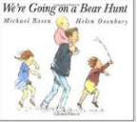  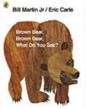  Busy Bears |   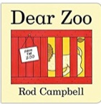  Brilliant Books | 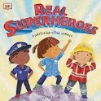  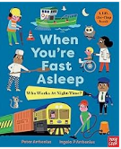  People Who Help Us   | 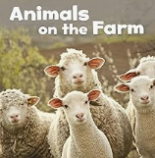  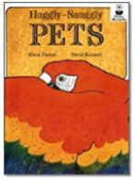  Amazing Animals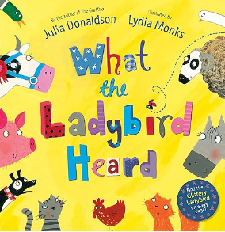
Focus Books |  |  | -Brown bear, brown bear, what do you see?  -Goldilocks  -We’re going on a bear hunt  -Where’s my Teddy?  -I am Bear | -The Tiger who came to tea  -Dear Zoo  -Shark in the park | -Non -fiction books; people who help us  -A superhero like you  -Real superheroes  -When you’re fast asleep, who works at night time? | -Doing the animal bop  -The huggly snuggly pet  -Animals on the farm  -What the ladybird heard  -Love your World  -Let’s Look at feet
Personal, social and emotional development | PSED is interwoven into all elements of the EYFS in each term  Self-regulation:  - Follow 2 step instructions  - Show focus on a member of staff for a short period of time  Managing self:  - Select and choose resources to help them reach a goal  - Increasingly follow rules  - Develop appropriate ways of being assertive (Stop, I don’t like it.)  - Begin to describe and recognise simple feelings – sad, happy, angry, worried, tired, scared  Building relationships:  - Become more confident with others in social situations  - Play with one or more children extending and contributing to the play  - Begin to find simple resolutions to problems (take turns being the main character in a role play)  - Begin to grasp how someone else might feel
Health and hygiene | • Use the toilet independently • Follow steps and guidance to wash and dry hands • Brush their own teeth • Begin to show and understanding of the need for good hygiene for everyday life • Understand some simple healthy food and drink choices
Communication and language Listening, Attention and Understanding | C&L is interwoven into all elements of the EYFS in each term - Rich language environment. - Listening and engaging in story time daily - Learning Nursery rhymes and Number rhymes - Positive play  - Begin to listen to longer stories and recall some key events  - Begin to pay attention to more than one thing at a time  - Understand clear 2 step instructions  - Understand and answer ‘why’ questions  - Respond appropriately in simple conversation
Communication and language  Speaking | - Retell familiar Nursery and Number rhymes  - Speak in longer sentences (4 to 6 words)  - Start a conversation and take turns speaking and listening  - Use talk to organise their play
Physical development  Gross Motor | Gross motor skills are practised throughout the year, mostly outside- using large muscle movements (painting water on blackboard, waving streamers, crawling under play equipment/climbing, rolling large hoops etc) What’s the time Mr Wolf, bikes, P.E equipment available daily all year,  • Use alternate feet to climb up apparatus or stairs • Change direction on trike • Demonstrate control on a balance bike using alternate feet and be able to change direction • Hold a position (balance) during games such as on one leg • Travel by hopping • Show control over the body to quickly stop and start movements such as walking, crawling and running • Move their body to music and follow instructions to move to the rhythm of the music (gallop, slither etc) Copy the adult • Make a choice about how to move across an object e.g. walk, hop, crawl across a plank or beam • Work with others to move objects safely such as wooden plank
Physical development  Gross Motor | Autumn |  | Spring |  | Summer
 | Explore moving our bodies in different ways –skipping, crawling hopping, jumping, and landing on two feet  Move their body to music, showing control when to stop and start  Move their body to music and follow instructions to move to the rhythm of the music (gallop, slither etc) Copy the  adult |  | Safely move equipment  Stop and start on a tricycle  Explore using a balance bike with alternative feet, steering around a simple route  Gain confidence using alternate feet on a balance bike  Make a choice about how to move across an object e.g. walk, hop, crawl across a plank or beam. Move across obstacles on the playground |  | Begin to explore space, recognising the position of their body in relation to others  Compete in simple races – running at speed, following instructions to complete an obstacle course  Begin to roll and stop a ball
Physical development  Fine Motor | • Use one-handed tools such as paintbrushes, pencils and scissors  • Make snips in paper using scissors  • Snips paper moving scissors forwards  • Begins to cut in a line holding the paper with their non dominant hand  • Show a preference for a dominant hand  • Progress towards holding a pencil with a modified tripod grip to show increasing control  • Demonstrate growing independence putting on a coat and shoes, begin to do up zips and poppers  • Begin to use a knife and fork
Literacy  Comprehension | • Engage in conversations about stories they have listened to – express simple likes and dislikes  • Retrieve answers from a story answering what and who questions  • Learn new vocabulary linked to stories, rhymes, non-fiction and poems  • Join in with repeated refrains in familiar stories
Literacy  Comprehension | Autumn |  | Spring |  | Summer
 | Join in with repeated refrains in shared familiar stories  Express simple likes about a shared story |  | Answer who and what questions linked to stories shared  Express simple likes and dislikes about a shared story |  | Answer who and what questions linked to stories shared  Express simple likes and dislikes about a shared story  Use new vocabulary in their play and in conversations
Literacy  Word reading | • Listen carefully and discriminate between sounds  • Recognise that print has meaning and that it can be used for different purposes  • Develop book handling skills - recognising that we read left to right, top to bottom. Turn pages with care and name the different parts of a book – pages, front cover, back cover. Know pages have an order.  • Develop their phonological awareness, so that they can: - spot and suggest rhymes - count or clap syllables in a word - recognise words with the same initial sound, such as cat and cup
 | Autumn |  | Spring |  | Summer
 | Phase 1 activities – developing listening and attention skills. Focus on sound discrimination  Rhymes and stories – discriminate between sounds  Develop book handling skills |  | Parts of a book  Words with the same sound  Rhymes and stories – clap syllables, spot and suggest rhymes  Rhyming books  Fiction and non fiction |  | Begin to identify initial sounds and develop oral blending skills
Literacy  Writing | • Ascribe meaning to marks  • Make marks during play  • Form different movements using fine-motor skills – straight lines, diagonal lines, circles, spirals, clockwise and anti-clockwise movements  • Begin to form recognisable letters  • Write some or all of their name
Literacy  Writing | Autumn |  | Spring |  | Summer
 | Focus on movements and fine-motor skills required for writing such as straight lines in different directions, clockwise and anti-clockwise mark making for curved lines |  | Ascribe meaning to marks in play  Applying appropriate pressure to make a mark |  | At least first letter of name written correctly  Ascribing meaning to marks  Beginning to record some sounds in sequence
Maths  Number | Only using numbers to 5 in the environment, using counting rhymes – (ascending numbers), Maths area and real life problems  - Develop fast recognition of up to 3 objects, without having to count them individually (‘subitising’).  - Recite numbers past 5.  - Say one number for each item in order: 1,2,3,4,5.  - Know that the last number reached when counting a small set of objects tells you how many there are in total (‘cardinal principle’).  - Show ‘finger numbers’ up to 5.  - Link numerals and amounts: for example, showing the right number of objects to match the numeral, up to 5.  - Experiment with their own symbols and marks as well as numerals.  - Solve real world mathematical problems with numbers up to 5.  - Compare quantities using language: ‘more than’, ‘fewer than’.
Maths  Number | Autumn |  | Spring |  | Summer
 | T1: Recite numbers past 5. Say one number for each item in order  T2: Know the last number reached when counting a small set of objects tells us how many there are in total (cardinal principle) |  | T3: Show finger numbers up to 5  T4: Develop fast recognition of up to 3 objects, without having to count them individually. (subitising)  Link numerals and amounts for example – showing the right number of objects to match the numeral up to 5.  Experiment with their own symbols and marks as well as numerals – up to 5. |  | T5: Solve real world problems with numbers up to 5.  T6: Compare quantities using the language of more and fewer
Maths  Shape | • Understand key words that can describe their position – prepositions (off, up, down, under, above, besides)  • Describe a short, familiar route using positional language  • Extend and create ABAB patterns  • Use some sequencing language to describe an event ‘first, ‘next’, ‘last’  • Combine shapes to create new ones – a rectangle and a semicircle to create an arch  • Make simple comparisons between objects relating to size, length, weight and capacity using key language to compare two or three items  • Recognise and name 2D shapes in different orientations – triangle, circle, square and rectangle. Know how many corners they have  • Recognise that 3D shapes are solid.
Maths  Shape | Autumn |  | Spring |  | Summer
 | Explore shapes through play and combine shapes to make new shapes  Explore length and compare two objects using key language  Positional language |  | 2D shapes and their properties.  Explore combining shapes to make new shapes and describe  Prepositions  Animal patterns (Dear Zoo)  Explore repeating patterns |  | capacity – empty and full – water tray  Weight – heavy and light  Using prepositional language and describing a familiar route  Insect/animal patterns. Patterns in nature
Understanding the world  Past and Present | • Begin to make sense of their own life-story and family history
Understanding the world  Past and Present | Autumn |  | Spring |  | Summer
 | Discuss the notion of growing up.  Life cycle baby to adult.  Photos of own family to discuss.  What do I live in (house, flat etc) |  | Share past experiences- holiday news using photos |  | Explore change over time. Talk about how they’ve grown.  Transition to school
Understanding the world  People, culture and communities | • Show an interest in different occupations and recognise people who can help them – emergency services etc  • Continue to develop positive attitudes about the differences between people  • Know that there are different countries in the world and talk about differences they have seen or experienced
Understanding the world  People, culture and communities | Autumn |  | Spring |  | Summer
 | Marvellous Me- similarities and differences between us- features of faces, hair styles etc  Family celebrations and events celebrated by different groups of people – Christmas, Diwali, Halloween  Remembrance |  | Look at world map- where have you visited/where are your family from etc  Photos/videos of different countries/cultures |  | Looking at occupations- dentist, teacher, police officer etc  Roleplay 999 call
Understanding the world  Technology | • Explore how things work  Mechanical equipment available- wind up toys, pegs and boards
Understanding the world  The Natural World | As well as specific group times, there are also opportunities to explore the following through enhanced provision:  • Use their senses to practically explore natural materials  • Explore collections of materials with similar or different properties  • Talk about changes to materials  • Plant seeds and take care of plants  • Understand the key features in the life cycle of a plant and an animal  • Recognise the need to care for the natural world  • Explore and talk about different forces
 | Autumn |  | Spring |  | Summer
 | Explore changes in autumn  Explore what happens on cold winter days – melting ice, frost  Season change to Winter |  | Season change to Spring  Exploring different materials and textures  Exploring torches and shadows in bear cave  Magnets  Melting chocolate  Caring for our garden/natural world |  | Season change to Summer  Talk about different forces (water tray)  Life cycle of plant/animal- cycle A- real caterpillars in nursery. Cycle B- Tadpoles in nursery  Plant seeds  Recycling
Expressive Arts and Design  Creating with materials | During Continuous Provision, there is always opportunity to practice skills  • Join different materials together using tape and glue, paperclips, fasteners etc.  • Make choices about which materials to use when creating  • Create closed shapes with continuous lines when drawing to represent objects  • Begin to include details on their drawings – eg an enclosed circle for a face with an attempt at features  • Represent feelings, noises, movements through drawing  • Explore colour mixing with paint
Expressive Arts and Design  Creating with materials | Autumn |  | Spring |  | Summer
 | Use large-muscle movements, explore with variety of mark making tools  Drawing: (Self-portraits) Cut features from magazines and add to paper plate.  Draw features to represent own face.  Painting and mixed media: Learn colour names, explore colour mixing. Experiment with different brushes.  Study artist: Pollock. Firework splatter paintings/Van Gogh starry night  Transient art nature faces  Models with playdough, lego, bricks |  | Drawing: with more detail  Weaving  Texture: Tuff tray- explore different textures. Links to Science  Sculpture and 3D: Models with playdough: animals etc. Lego, bricks, make arches etc  Junk modelling – joining different materials with split pins/tape  Junk model instruments |  | Drawing with more detail-add emotion, movements to drawings  Craft and Design- threading, create repeating patterns  Folding paper
Expressive Arts and Design  Being imaginative and expressive | During Continuous Provision, there is always opportunity to develop storylines through play in role play areas, small world areas and construction both indoors and out. There is the stage area in the garden for musical instrument exploration  • Take part in pretend play imagining objects are other things from their experiences  • Begin to make their own small worlds to act out storylines  During Continuous Provision, there is always opportunity to explore instruments (music area/stage in the outside area)  • Listen with increasing attention  • Respond to what they hear expressing simple feelings and thoughts  • Remember and sing entire songs – such as Nursery rhymes, days of the week songs etc.  • Sing to match the pitch and tone of another person  • Create their own songs or improvise around a song they know  • Play instruments to express their feelings and ideas
Expressive Arts and Design  Being imaginative and expressive | Autumn |  | Spring |  | Summer
 | Nursery rhymes- loud/quiet, high/low  Environmental sounds  Listening to each other well  Listening walks around classroom/garden  Stories with sounds in  Ring games and action songs  CD player- diff types of music Jazz, classical, pop etc  Make sounds from everyday items  Explore instruments  Christmas songs |  | Clapping names/identifying syllables  Repeating a rhythm  Listening to and dancing to music from different cultures  Explore how sounds can be made  Singing nursery rhymes loud/quiet, high/low  Call and response songs  (with more accuracy, not shouting)  Hide instruments- guess the instrument  Make own instruments |  | Watch musicians play instruments  Name instruments and how they are played  Use apps- record their music and play back  Listen to music while painting/drawing  Clap and tap to the pulse  Watch musicians from different cultures eg India/Africa compared to UK  Create own songs to match mood eg stomping round garden, jolly fast tone. Slow- calming  Make own instruments
Role play area  suggestions | Home corner  Supermarket  Doctors | Birthday party  Dressing up- cultural clothes  Santa’s workshop | Home corner/office  Superhero HQ  Bear cave  Goldilocks roleplay | Whatever Next roleplay-large boxes/wellies etc  Café  Post office  Vets | Dentist  Police station  Hairdressers  Airport  Hospital | Pet shop/vets  Minibeast lab  Science lab

